**A Magical Year**

You know you’re one lucky soul when you find it hard to collate all your favourite performances down into one page… Fortunately for me (and maybe slightly lengthier read for you), I’ve have had one magical year.

Rewind one year ago, if you were even to mention even a few of my sporting highlights I think I would have had a slight chuckle; in disbelief.

The year started off with a bang; a minor but grateful podium at the local Surf Breaker Triathlon with a swim-bike-run-swim-bike-run format keeping things more interesting. Now (January at the time) was the calling to put some hard yards in, in prep for a huge summer to come. Base work is greatly important for triathlete’s, especially when you have race back-to-back, it allows you to reach those three percenters when travel-fatigue and lower training hours kick in. Before I delve into my race results, I would like to pause and thank my coach Bruce Hunter & previous TriNZ HP Director; Mark Elliot for setting up the ideal training environment in Cambridge over the NZL summer. I can ‘hand on my heart’ say I would not have achieved anywhere near what I did this year without the foundation laid by my support system; they truly set me up for my successful year to come. Now the good stuff….

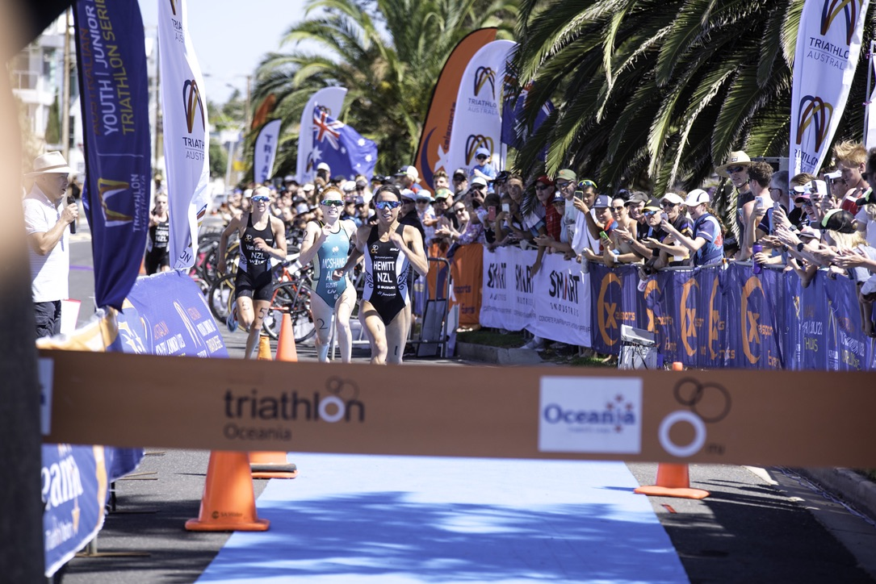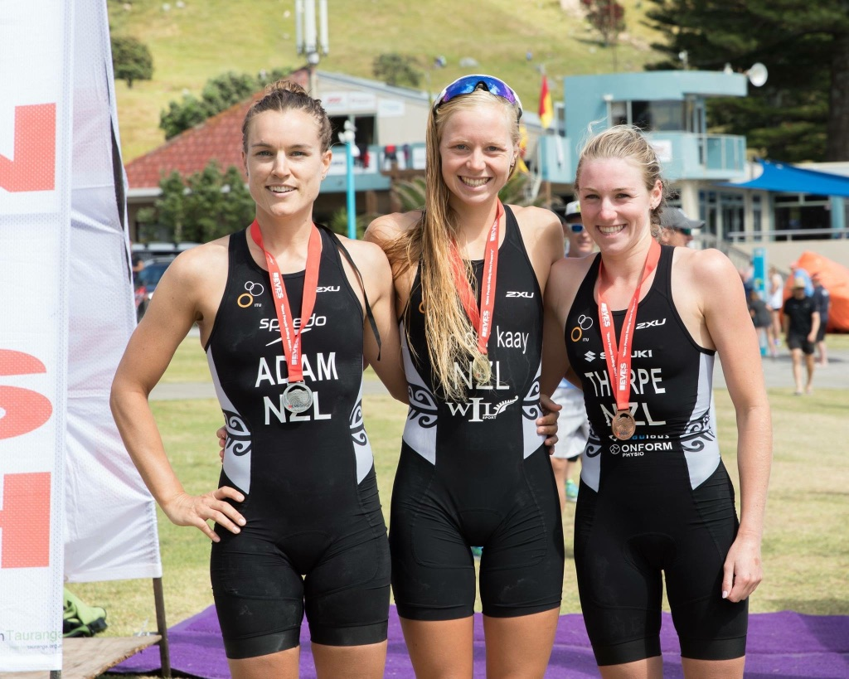

Oceania’s was my first proper race of the season, and when I found myself running beside the legends & Olympians of the sport; Hewitt & McShane, well it took me by a bit of a surprise, almost feeling like I did not belong! I ended up in a sprint finish, (coming third) but nonetheless walking away with a huge smile on my face but also with an important learning that I do belong in the top percent of the sport, boosting my confidence (importantly so) for the following races.

**Mooloolaba World Cup <3**

This world cup has always been a favourite of mine; I’m not sure whether it’s because of the holiday destination or the race course itself, I’m excited to be there either way! Kicking off the race in a beach style surf start is always going to suit me with a surf background, thus starting off my debut 2018 WC with an upper hand. Swim, bike, run later; I found myself in the money running for third, and in my first Olympic distance of the year too! A few matches too short, I lost the running battle to the lovely Angela Olmo; but again, walking away with a huge smile; 4th in the first World Cup of the year!

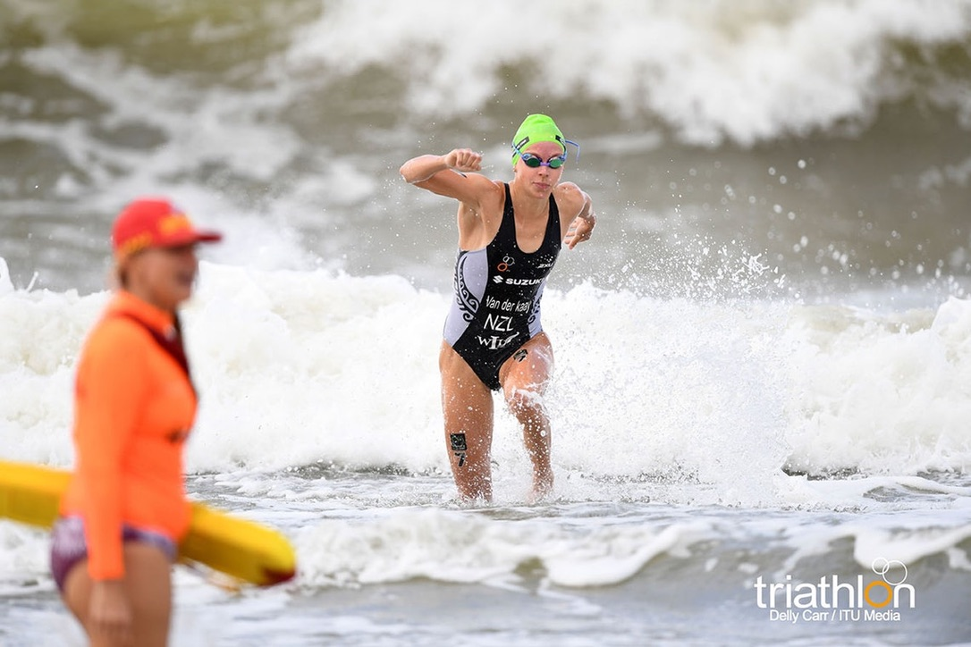

**New Plymouth World Cup**

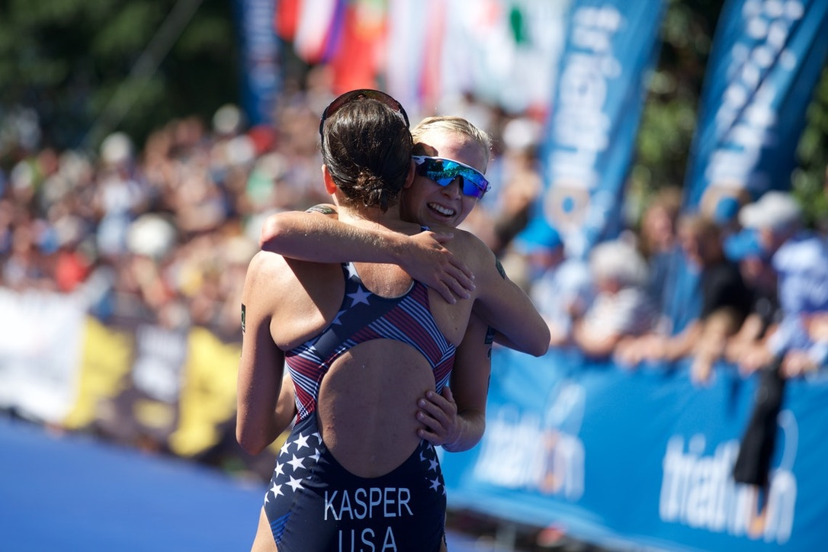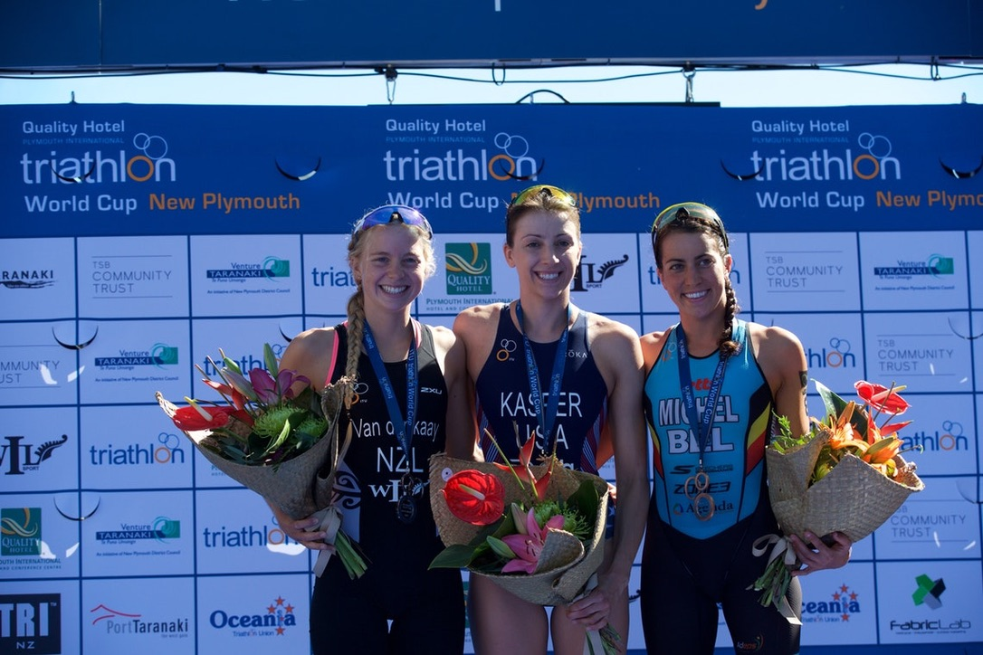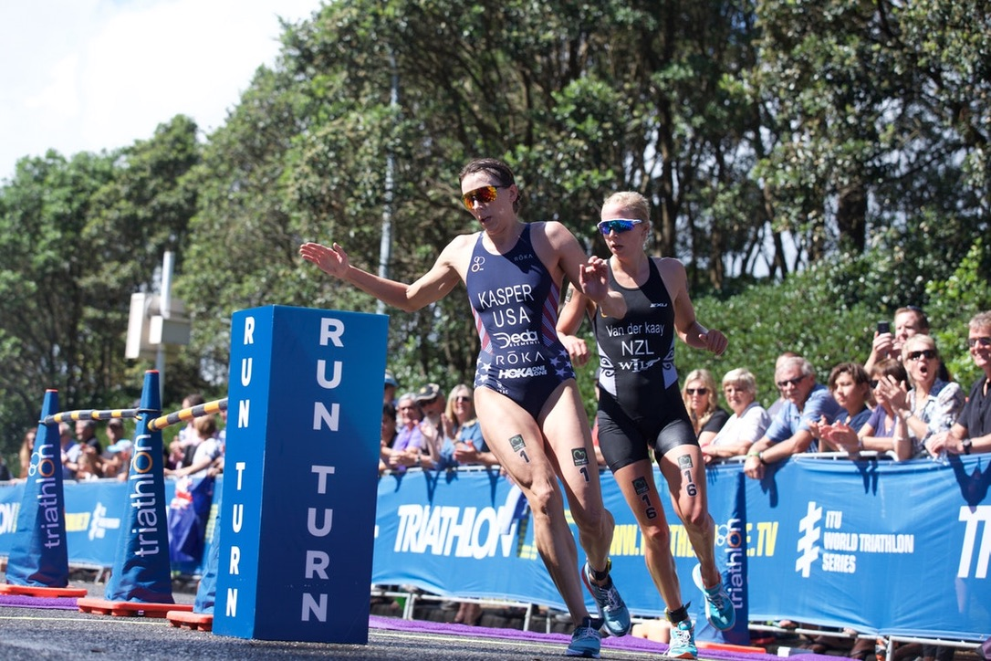This race will always be very special to me, and one to remember. After my coach’s quick confidence tips, I attempted to remain cool, calm & collected with the stacked list of international starters. On the final turn of the run, I couldn’t believe I was running for podium let alone gold on home soil! The experienced American had the extra two percent in the last kilometer, but again with what it seems to be becoming a repetition, I was in utter disbelief that I cracked my first WORLD CUP PODIUM.

Scottie T

Scottie T

Scottie T

**GOLD COAST COMMONWEALTH GAMES**

It is hard to put in words what my first games was like to experience and is a question I get asked frequently. Bottom line, it was some of the best moments of my life and career so far. The crowds, the views, the racing, the support, the emotions, and of course the superstars in the food hall all add to one special week of my life.

Race day arrives and easily said, I was the most nervous I had been before any point of my life… Lining up on that pontoon, next to a small but highly competitive field of the strongest commonwealth athletes. To add to the nerves, the spotlight is on you with cameras, media, alongside crowds and the notorious ‘heartbeat’ soundtrack they play before the starters hands (that I swear is made to give the athletes nightmares)… BANG, with adrenaline and caffeine pumping through my veins, I was off for an hour of high-intensity swim-bike & running. When you’re in the zone, time flies by and there I was; on the run, behind some of the biggest names in the sport. Pushing until the very end, I ran myself into 7th place welcomed home by so many friends, family, and supporters; day made.

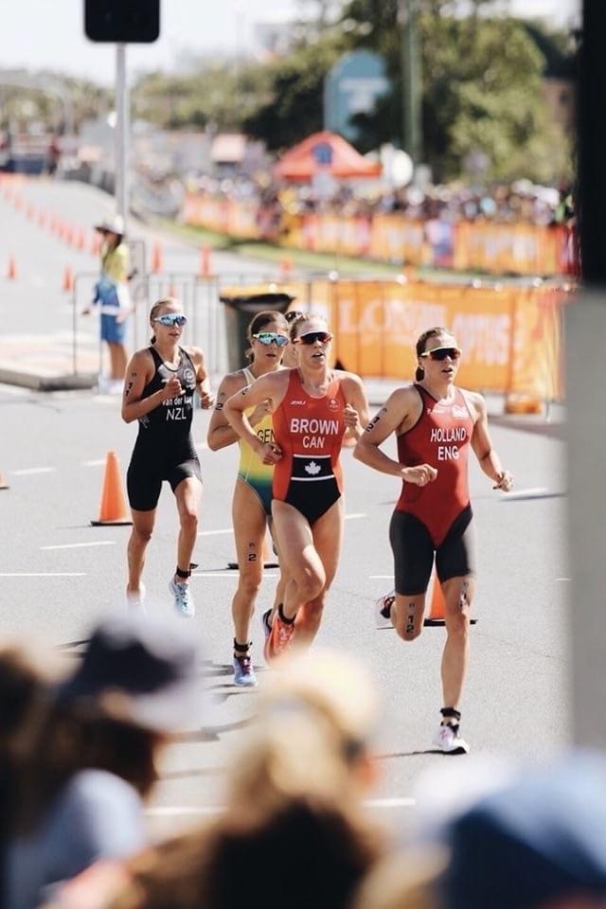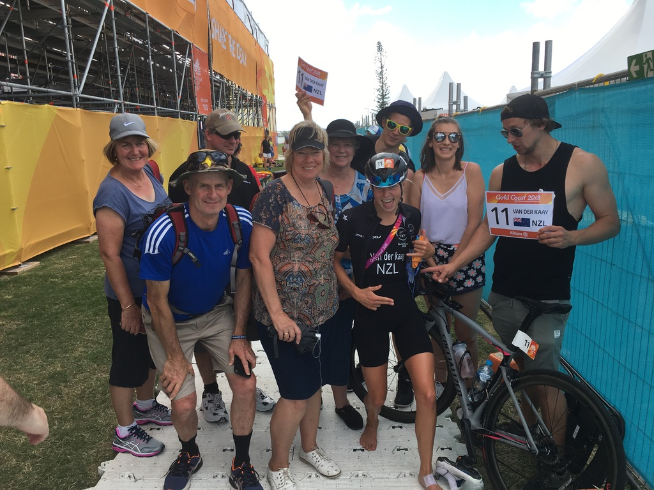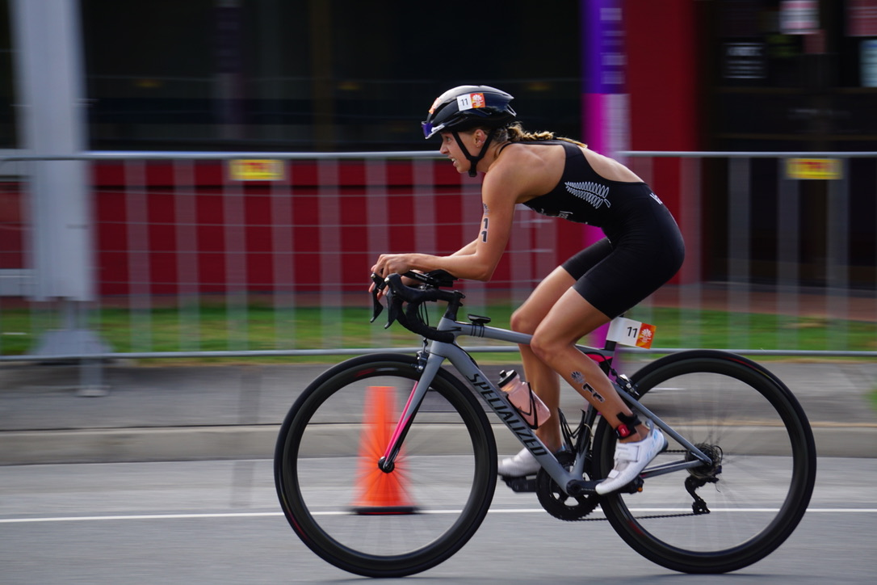

Kye Wylde

My work was not finished. With only being able to briefly say hello and catch my breath with my family, the recovery protocol loomed as the very important Mixed Team Relay event was to be held in the days following. Protein shake, cool down, ice bath, massage, and elbow by Rone (ouch). Then back into refocusing for the next event.

**MTR CWGs**

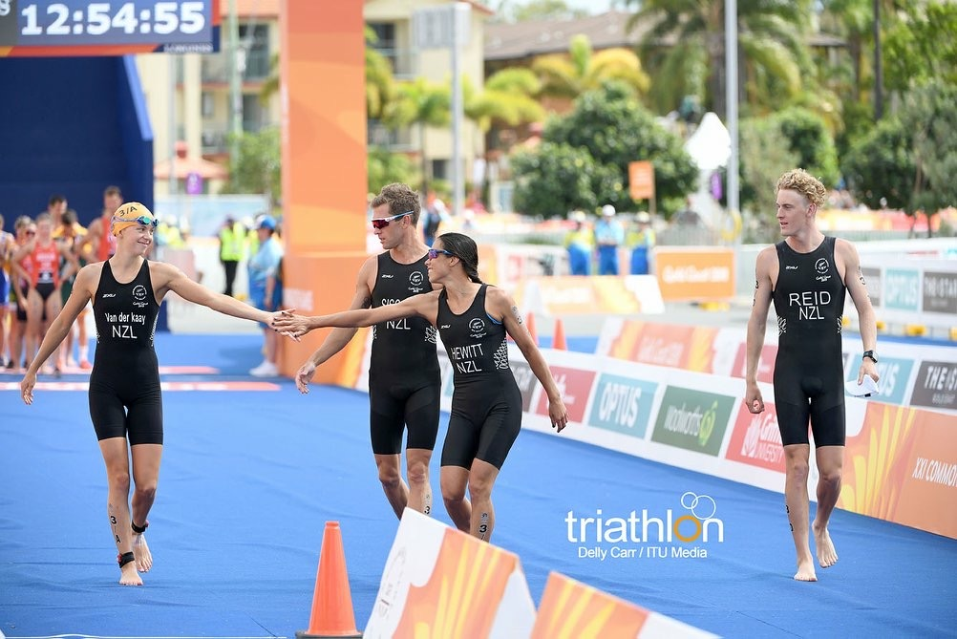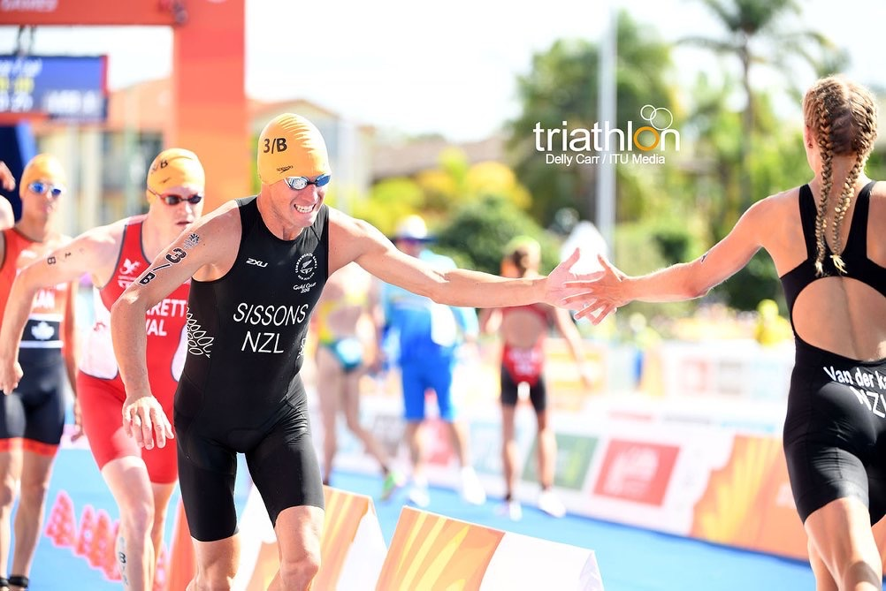

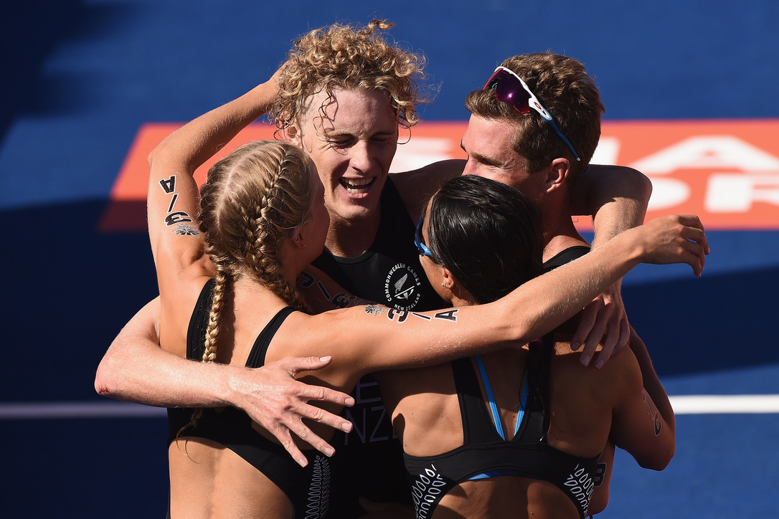With great relief that the Individual event was completed to satisfaction, but it was now time to ‘rip-sh*t & bust’ for my teammates and NZL in the little black suit. I was in the starting leg, so again nerves were very present to execute my part and handoff in a position where we were still in for the money. I handed off to Ryan who tagged Andrea, who then handed off to our anchor; Tayler. We all had fantastic performances, and with pure delight, we were over the moon to see Tayler sprinting around the second to last bend in third position holding off Canada! I don’t think I could really believe it at the moment, there we were; with the very likely possibility that we could podium at the Common Wealth Games!

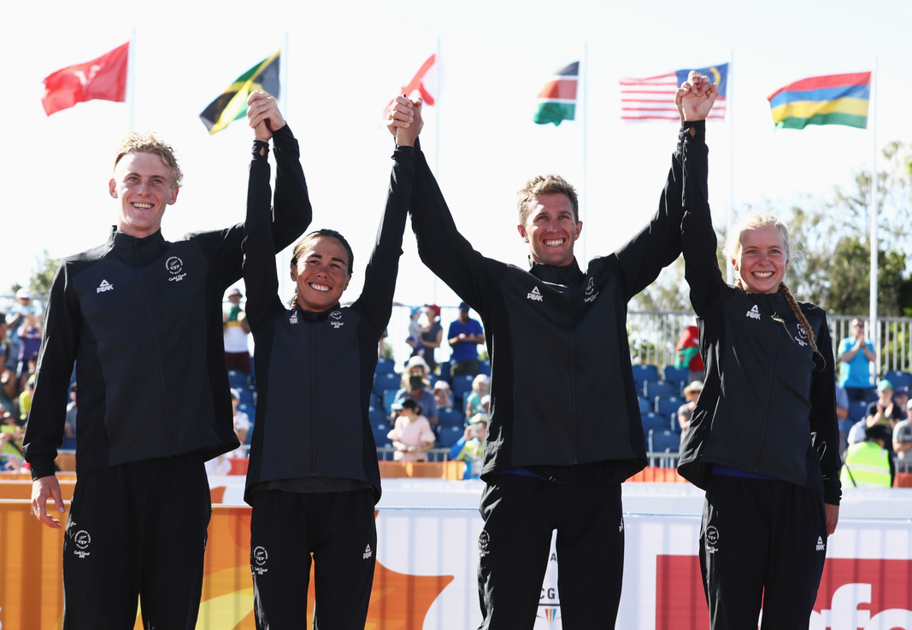

Tayler ran across the line utterly exhausted and excited at the same time, where we all welcomed him back with huge smiles and hugs; TEAMWORK. This day was one of the most amazing experiences to date, from crossing the finishing line it was all go. TV and radio interviews, suiting up for the podium, walking through the crowds followed by multiple congratulations and just being treated like superstars! We were then chauffeured to the NZL House to celebrate our success (after waiting 2 hours in drug testing for Tayler to pee of course). Further superstar treatment in the NZL house was to follow, being handed delicious cheesy quesadillas and champagne on arrival. Further interviews continued then finally we were able to mingle with family & friends, being able to reflect on the day as well as meeting other superstars of the sport!

**European / International Campaign**

After a solid end of summer training in NZL, I was ready to fly again; both literally and metaphorically ☺. Nottingham 🡪 Leeds 🡪 Antwerp 🡪 Wuutswezel 🡪 Spain.

4 races in three weeks, there was no shortage of racing that’s for sure! Each race contained many highlights along with learning curves that set me up on my ‘work-on’s’ for the NZL Training camp held in Banyoles, Spain.

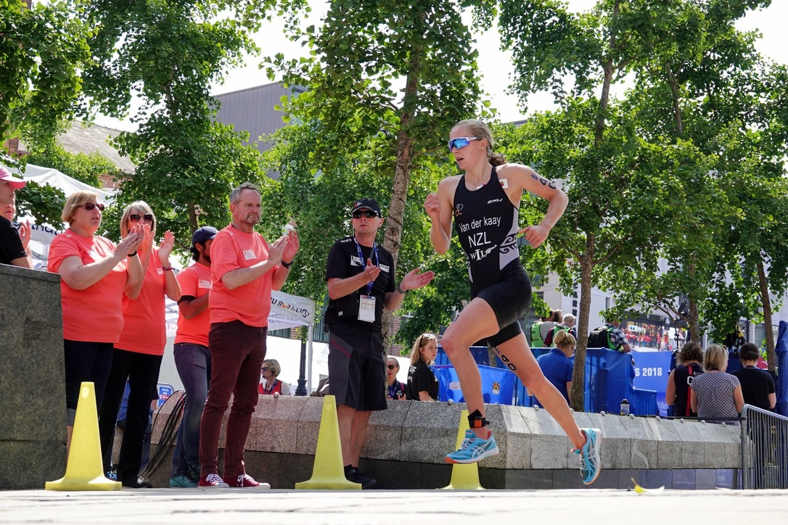WTS Leeds was one of my most challenging yet satisfactory races of 2018 season. It was hard. Like, insanely hard. Right from the starting horn, I was red-lining the whole way, from sprinting through T1 to time-trialling on the bike to catch up to the front group, to then yo-yo-ing through the criterium-style bike course in and around the city of Leeds. And I wasn’t alone. Girls were dropping off like flies, with around 20 girls who did not finish. 40km later, I was relieved to reach the run, still in the front group of girls, however rather cooked using all my matches to stay there. Running… Felt like dragging bricks through water, until the 7.5km mark when suddenly it was like my legs had a light-bulb moment and learned how to run again! I stormed home in the last lap, passing three athletes and sneaking myself into my first Top 10 WTS series; another goal of the year ticked off.

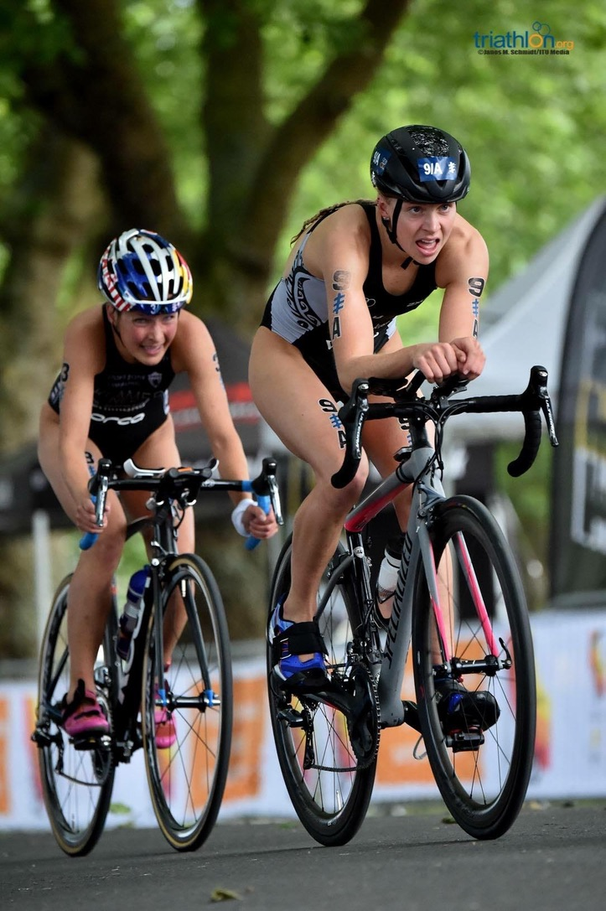

I was as happy as a kid in a candy store to 1) fly to Spain and begin proper training again and 2) end my racing block with a win at Wuutswezel ETU. After multiple learning curves from the past 3 races, I was able to tweak my performance and execute the triathlon to satisfaction. It was just one of those days where everything ran smoothly, and I felt totally in control. These are my favourite days. ☺

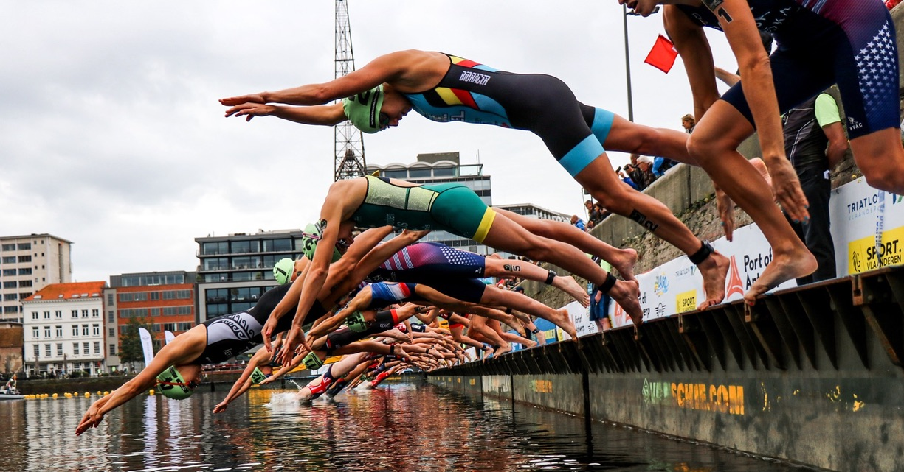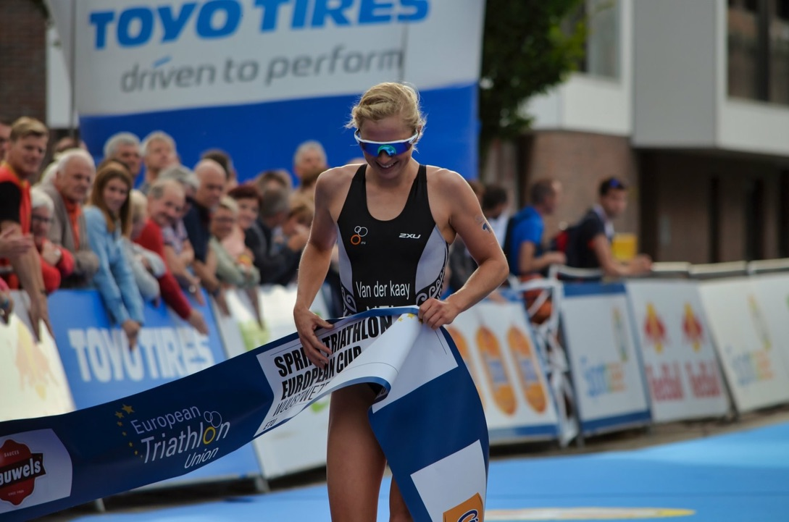

**Spain and Siesta Time**

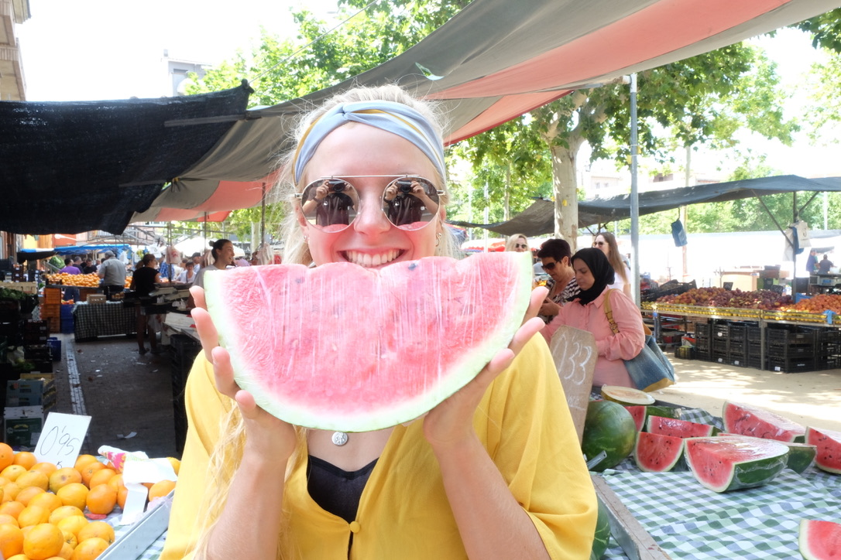Back into routine, train, chocolate oats, nap repeat. I’m rather comfortable with this lifestyle, which isn’t very surprising! We were back in business with all the NZL triathletes slowly trickling into Banyoles from other races around the world. Banyoles is the perfect place to put in the hard yards while living a lush lifestyle. There are endless mountains to climb, gravel trails to run and a beautiful lake to swim in. Oh, and did I mention the delicious fresh summer fruit and gourmet pizzas from the local down the road? This picture below sums up quite nicely how I feel about Banyoles don’t you think?

These three weeks of training were the best, most put-together training performances I have completed to date, and again I have to thank Mark, Bruce, and Chris for putting together a structured environment enabling us to train.

**Edmonton**

The final WTS before returning home, and I ready to withdraw some of the training deposited. Lining up for WTS Edmonton, I was excited and ready to go. Off with a great start, I found myself in touch with the front group, ready to hit the bike hard. Boom. In a second, I was down on the pavement, confused and a touch sore. I quickly pulled myself together ready to jump back on my bike only to find a puncture. Heart-broken. Nevertheless, I ran to the wheel station, changed wheels and hit it. But, unfortunately, the girls & the race were gone. I was utterly gutted to pull out (something I would never really do) but I had a Mixed Teams Relay the following day to think of.

Filled with anger and disappointment, I channelled this all into my next race. And man did it pay off. I’m pretty fresh on the WTS circuit, so to stick with the front girls is an achievement, but to run away from them, I think caught the commentators and spectator’s attention…

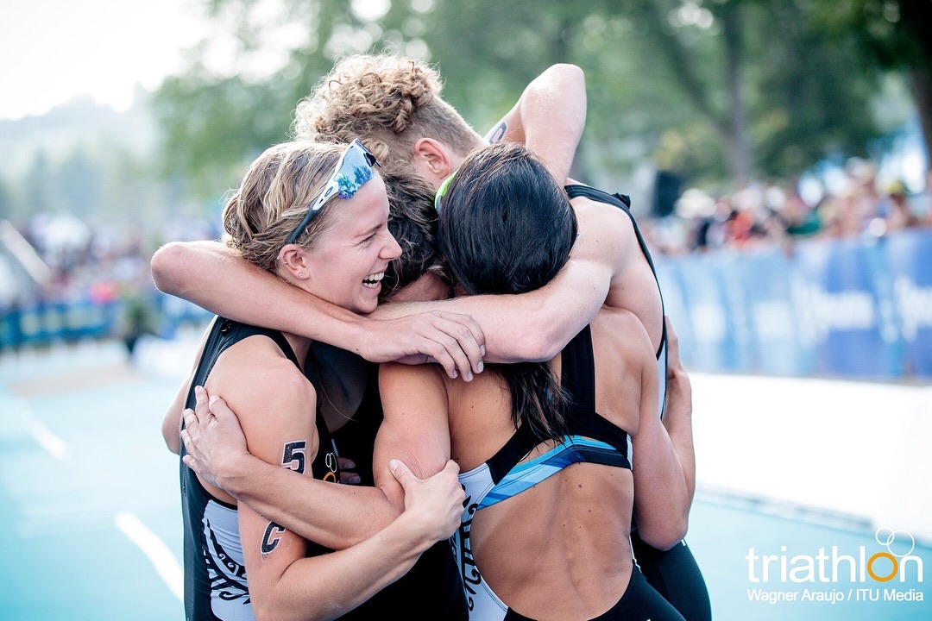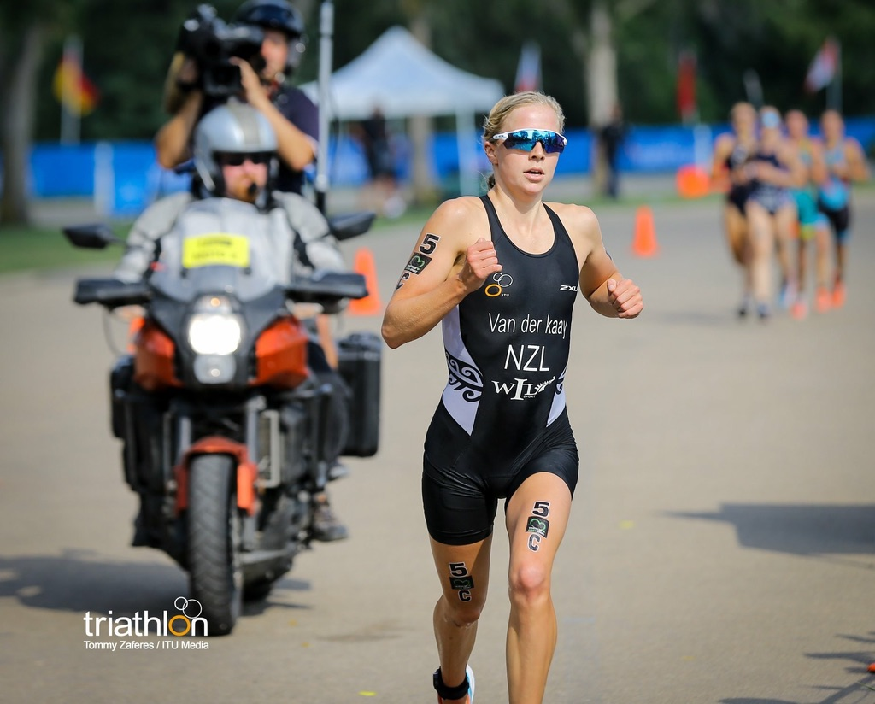Feeling totally controlled and buzzed from the adrenaline, the crowd’s energy, and the speed at which I was running, I tagged Hayden with excitement. Just like that, from being heavily disappointed the previous day, it all turned around into completing one of my best races to date (again)! Hayden had an insane leg and outrun some of the best athletes on the circuit, running us onto the podium!!

**Home & Gold Coast**

Oh, the joys of travel… As an athlete, you get to see some amazing destinations, but does come at a small and tiring cost, hours and hours spent in airports and cramped up in airplane seats.

After a short stint at home, off we were to the beautiful Gold Coast; Australia. More decent training and warmer weather were to follow, making training just that bit more enjoyable ☺. However, as gutted as I am to say, I think my body was finally starting to take the toll of the big and exciting year I had completed so far! As pumped as I was to get to U23s World Championships, I found motivation and energy slipping, my body was just; tired. Nevertheless, I pushed on to the final and gave it everything I had in the tank! My performance was pretty good too! I found myself in the running for the podium; my goal from the start of the year! I went out hard on the run, but just like the start of the year, the lovely Angela Olmo had the extra gears on the day and took the podium. Bittersweet being just off the podium, but I was happy to be in the running for the top 3, considering the way I felt leading into the race, and extremely happy with my progress over the past year. Thus happy!

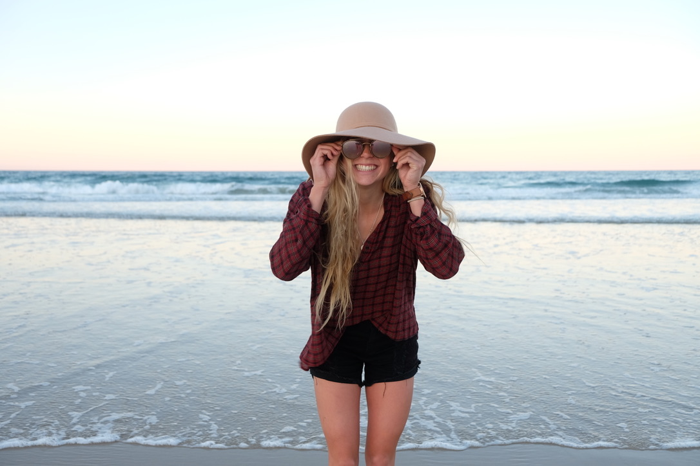

**Tongeyong WC**

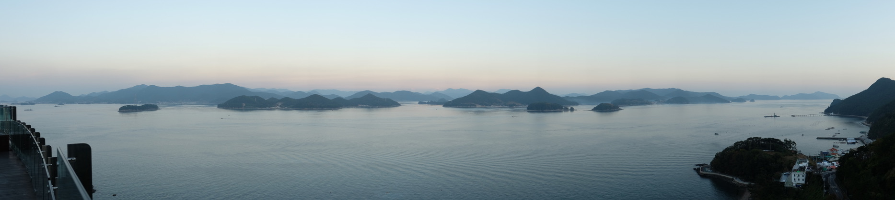The final push of the year. Just missing out on the podium, I was extremely motivated to hit another performance and execute to satisfaction. Four good weeks of training was laid down in my hometown, being very happy to be on home soil. Time flew, and it was time to pack for the beautiful small fishing town of Tongeyong; South Korea. By far my favourite Race hotel I’ve been fortunate to stay in so far. The views from the balcony explain it all.

Ready to rip the final race of the season, I was off! Coming out comfortably in the front pack, with a decent gap over the second group, I was in the running! Unfortunately, the second pack caught (which contained very quick runners), and it was all down to the run. Again, I went out with aggression, however, my legs didn’t seem to respond as they usually would, just feeling a touch heavy to reach those extra percenters that make all the difference in a race. I ran myself into a top 10 WC, which I’m happy with but in all honesty, I was there for more. I think my body was just ready for a rest regardless of how much I wanted to fire on the day and the weeks leading in, so from there I was SUPER happy to be on break and revitalise. And just to confirm with you all, I am so happy with my year, it has been the most consistent to date, where I don’t think I’ve missed one run session, and have ticked off many of my goals! Additionally, all top performances were top 10 this year which has only recently been brought to light! It has truly been magical, and I can’t wait to do it all again! (Post rest of course ;))

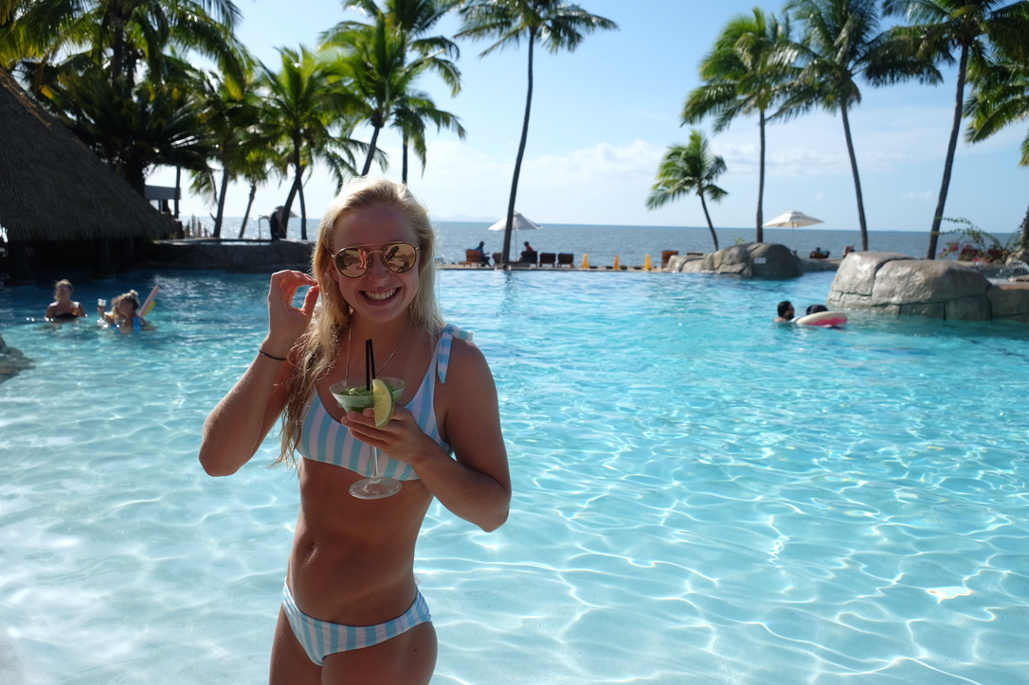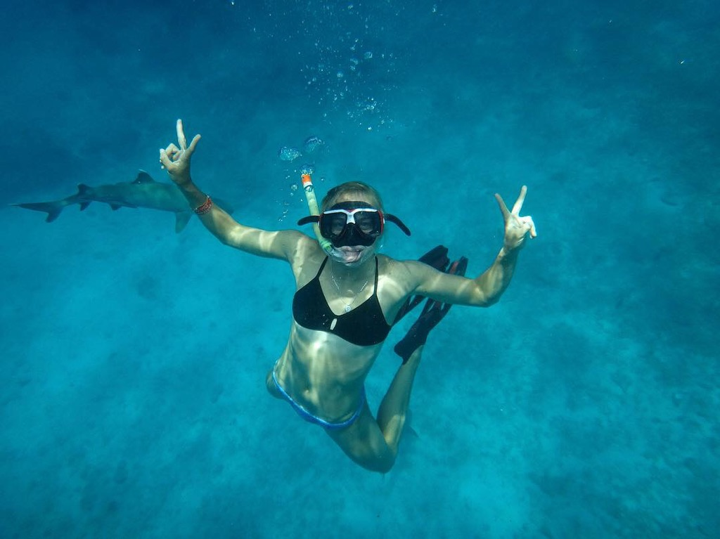

So, what now? Lots of beach time, no alarms and a whole lot of sunbathing. Oh, and Uni exam tomorrow that I should really be studying for… A special thank you to all of the athletes who trained with me, challenging me to do my best each given day and of course to my partners in crime who were there for me literally 98% of my campaign of 2018; Ainsley and Tayler <3

Also thank you to my friends, family, and supporters for the unconditional love and support.

To my major sponsors Phil & Cheryl London from WIL Sport, who are also doing incredible things with developing athletes worldwide.

To my coach; Bruce Hunter for putting up with me, alongside swim coach; Carl from St. Peters for the epic & lengthy sessions (they never disappoint), and Stephen co-coach.

Thanks to Steve Joe for keeping me in pristine health (least colds to date and touch wood, I maintain that)

To Rone, Dale and the HPSNZ staff for excess dry needling & keeping me in tip-top shape.

HPSNZ, TriNZ and Smiths Sports Shoes and Asics for supporting me and keeping me kitted up.

Thanks to Blueseventy NZ, Amanzi swimwear, Apex Windows, Evolution Cycles Hamilton, Specialized NZ and Massey Uni; every little bit helps.

And of course; Mumma and papa bear.

Cheers,

NVDK xx

